DATA FLOW DIAGRAMS

Data Flow Diagrams

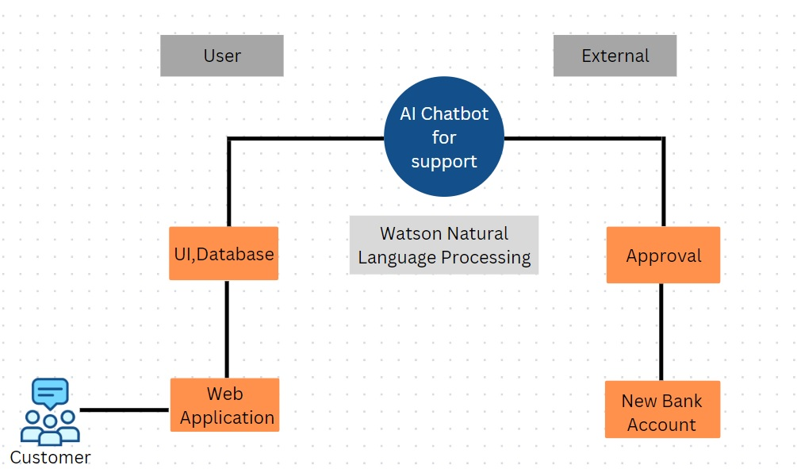 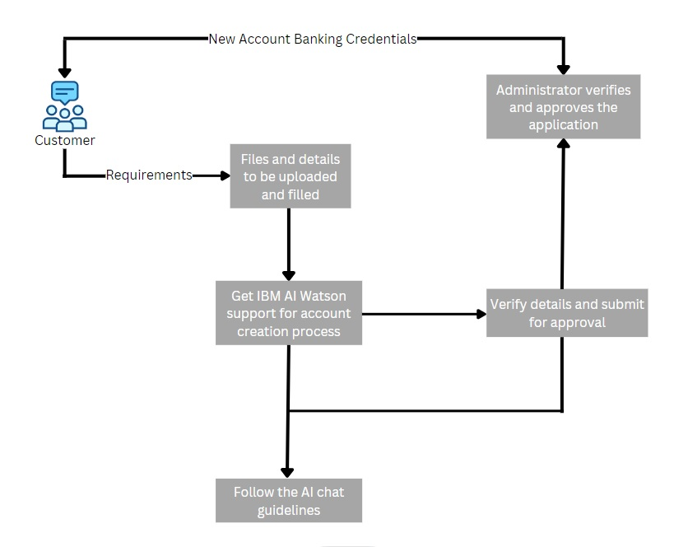

**User Stories**.

|  |  |  |  |  |  |  |
| --- | --- | --- | --- | --- | --- | --- |
| **User Type** | **Functional Requirement**  **(Epic)** | **User Story Number** | **User Story / Task** | **Acceptance criteria** | **Priority** | **Release** |
| Customer (Mobile user) | Registration | USN-1 | As a user, I can register for the application by  entering my email, and password, and confirming my password. | I can access my account/dashboard | High | Sprint-1 |
|  |  | USN-2 | As a user, I will receive a confirmation email once I have registered for the application | I can receive a confirmation email & click confirm | High | Sprint-1 |
|  |  | USN-3 | As a user, I can register for the application through Facebook | I can register & access the dashboard with Facebook Login | Low | Sprint-2 |
|  |  | USN-4 | As a user, I can register for the application through Gmail |  | Medium | Sprint-1 |
|  | Login | USN-5 | As a user, I can log into the application by entering my email & password |  | High | Sprint-1 |
|  | Dashboard | USN-6 | As a user, I can get the application completion status and files to be required to create the  account. | I can receive the completion status and create the account. | Low | Sprint-2 |
| Customer (Web user) | Registration | USN-1 | As a web user, I can go through many social  media websites, get the details and I can register for the application | I can access my application dashboard | High | Sprint-1 |
|  |  | USN-2 | As a user, I can get the details of the application through email. | I can receive a confirmation email to link my application | Medium | Sprint-1 |
|  | Login | USN-3 | As a user, I can link my google account to  register my application. | I can register my  application. | High | Sprint-1 |
|  | Dashboard | USN-4 | As a user, I can manage and get a detailed view of the application | Any changes in the application come to my knowledge while checking  dashboard. | Low | Sprint-2 |
| Customer Care Executive | IBM Watson |  | AI-based IBM Watson provides full support for the customer to guide and create new banking  account | I can fill in the respective details in the respective field. | High | Sprint-1 |

|  |  |  |  |  |  |  |
| --- | --- | --- | --- | --- | --- | --- |
|  | Support |  | Customer support is also mentioned for  describing important issues faced by the customer. | I can get the detailed solution for the queries | Medium | Sprint-1 |
| Administrator | Verification |  | The administrator can completely verify the submitted application. | I can get verified for application. | High | Sprint-1 |
| **User Type** | **Functional Requirement (Epic)** | **User Story Number** | **User Story / Task** | **Acceptance criteria** | **Priority** | **Release** |
| Admin | Approval |  | After completion, new banking credentials are provided to the customers. | I can get my banking credentials after approval  of the application. | High | Sprint-1 |